**Adding Survey**

**Step 1**: Gather CT, PT and QT combinations.

This is completed by calling the TFNs in question and selecting all possible combinations that result in you reaching the desired IVR result. It is important to *authenticate* you calls entering a valid response for Tax ID, Member ID etc. You can then query your calls via SQL to see what all combinations of CT, PT and QT were valid. With this information, we need to build a *Data Element Group* in Routing Services.

**Step 2**: Routing Services

In routing services we need to build a *Data Element Group* for our CT, PT and QT combinations and add it to the relevant TFNs. The *DataElementTypeID* will be DNIS/SourceDialedNumber in test and DialedNumberString in prod. With the type defined, enter an appropriate name. For example in WO80171 we used the name *PriorAuthSurveyDNISgroup* for our *Data Element Group.*

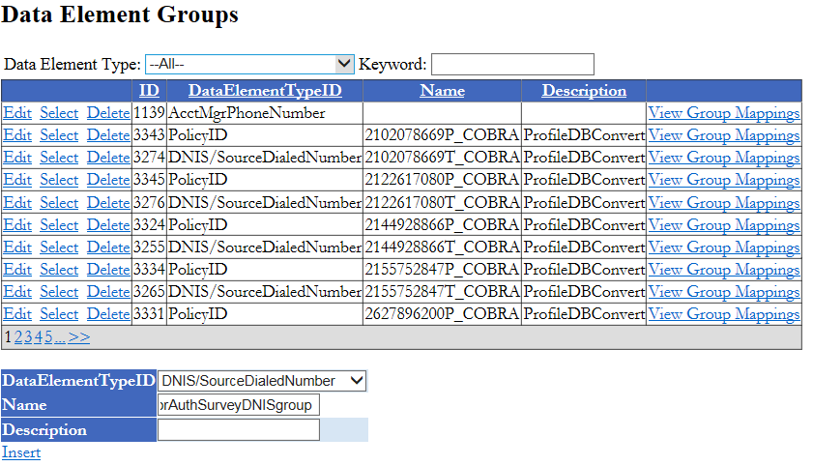

Once you have selected a valid name for your *Data Element Group* press Insert. Next we need to add our DataElement to the dispatch app in *Data Route Maps*. We select *Show / Hide Insert*, and in the Data Element Type drop down we select DNIS/SourceDialedNumber. For Data Element Group we add our Data Element and for Route, we select *DispatchAppName - SAXC08*. This is the application that plays the prompts for survey. Once these details are added we select *Add Mapping*.

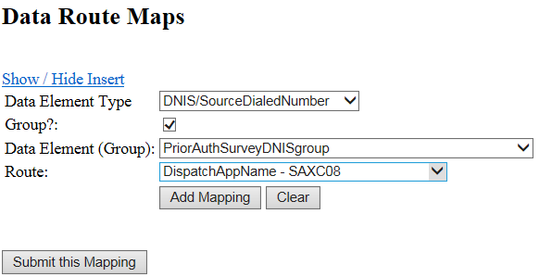

We still need to add additional mappings before we can submit this mapping. Next we want to add our PT, CT and QT. These are added the same way as our DNIS/SourceDialedNumber only the Group checkbox is left blank as this isn’t a data element group but a single data element check. Remember that in prod the type will be DialedNumberString and not DNIS/SourceDialedNumber.

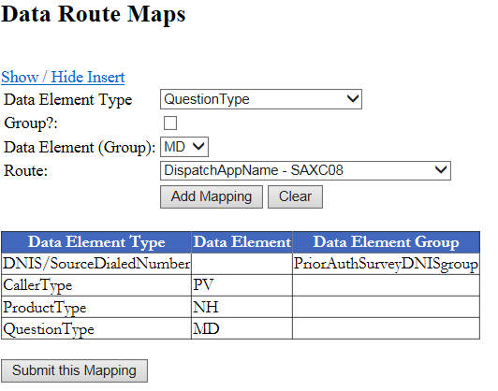

Now in Quick Edit we want to add our Data Element Group to our TFNs. For each TFN that this specific PT, CT and QT combination applies to, we add it to the *PriorAuthSurveyDNISgroup* group we created.

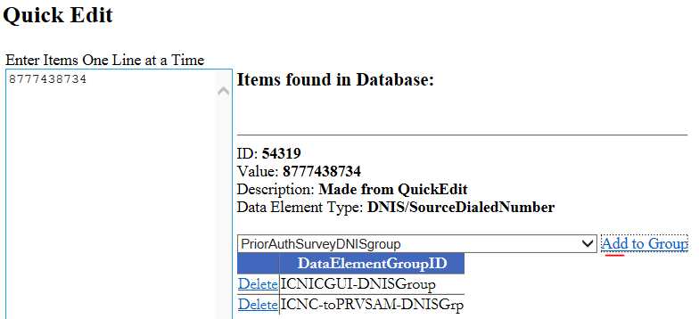

Once added this acts like a checklist of conditions. For calls that come into the system from these TFNs, Routing Services will check for the combination of PT, CT and QT defined in the Data Route Map. If the combination is valid, Routing Services sends the call to the *DispatchAppName - SAXC08*.

In some cases we want to check for more than one value for CT, PT or QT. In the same way that we can assign multiple TFNs to the *Data Element Group* named *PriorAuthSurveyDNISgroup*, we can also create a *Data Element Group* for any of these types. This would be configured in the same way as *PriorAuthSurveyDNISgroup* only it would be named appropriately, like *PriorAuthSurveyProductType* and would be configured as a Data Element Type of *Product Type*, like as shown below.

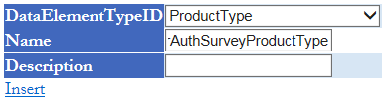

Then in quick edit we would search for the PT codes we want to add to the Data Element Group and add them to the Data Element as shown below.

